**Achievement 2 Note maker Lukas Maynard**

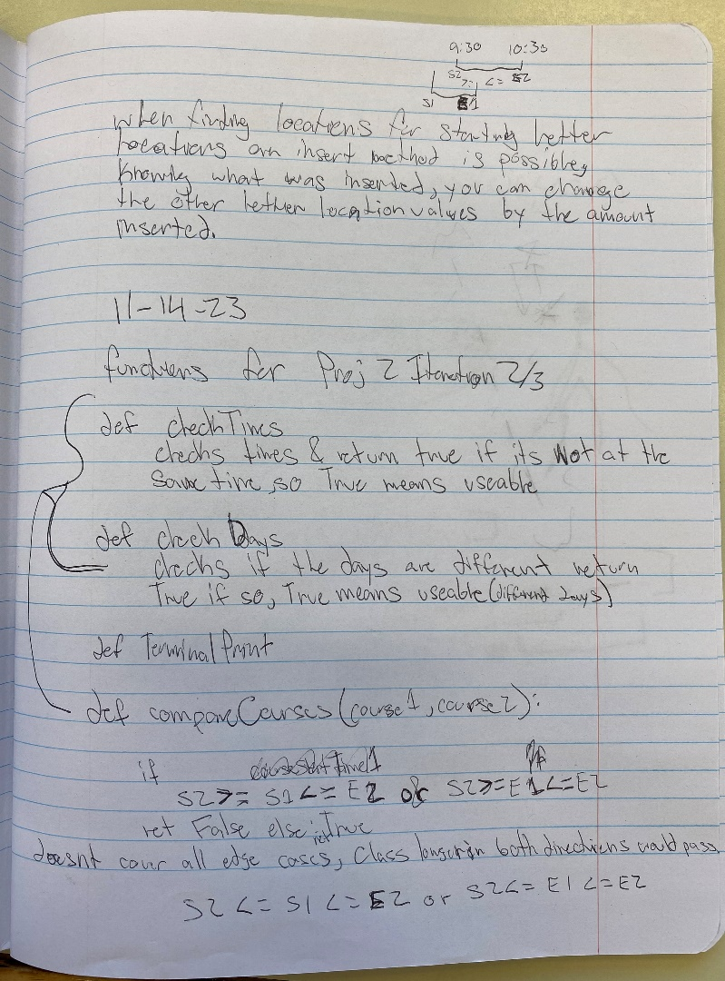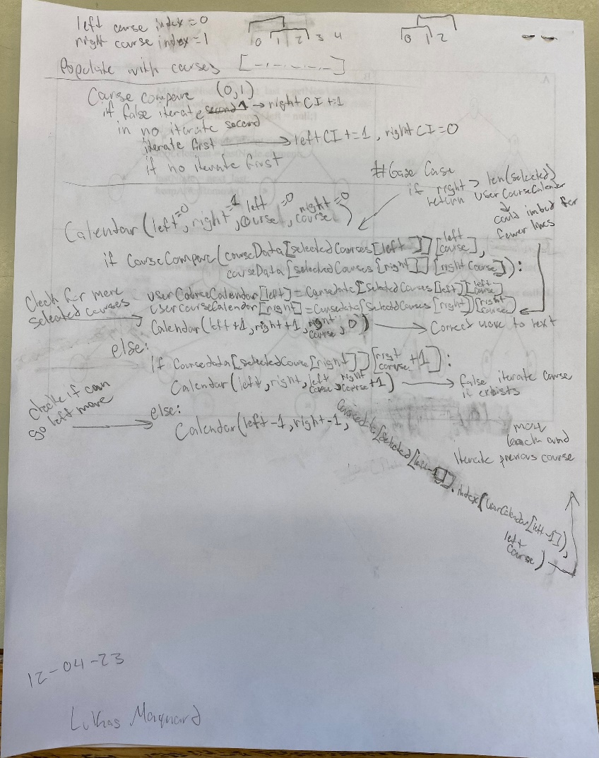

The first note page is from one of the first times Project 2 was shown to us. These ideas for functions that I scribbled down during class ended up being almost exactly what the final functions are. Specifically at the bottom of the page my initial ideas for comparing times were close to the final product.

The second note page is from the back of an assignment for another class. Out of nowhere I got an amazing idea for how to schedule the courses for Project 2. This was the extremely strong foundation for the final calendar building function. I decided to use 4 arguments 2 to track where we are in the list of courses and 2 to track the index of a specific course as every course number can have multiple classes. These arguments allow it to be recursive and I later learned in another class that this method is called a depth-first search. I learned a lot about recursion and searching methods from examining and implementing these notes into my Project 2 code.

Both pages spawned from random in the moment thoughts but ended up being crucial to the final product of Project 2. My “in the moment” thoughts are often my strongest and seemingly surmount from nowhere, so I always have paper ready to write down the next good idea.